CO2 Foodprint: Carbon Footprint Calculator

Members: Soma Badri (product owner), Riley Murphy, Destin Wong, Raymond Lee, Kelley Broderick (scrum master)

Sprint Date: Weeks 2-4

Revision Number: 3

Revision Date: April 14, 2021

TA: yogolan@ucsc.edu

**Scale for Story Points**

1: X small

2: Small

3: Medium

5: Large

8: X Large

13: XXL

20/21: Huge

Sprint 1 (mostly learning) week 2-4

|  |  |  |
| --- | --- | --- |
| Goal: Learning new resources | Story Points | Priority |
| As a developer, I want to make a drawing/diagram for each page (front page especially) in order to outline the app   * Have a meeting to diagram for each page (this is more of a group effort than individual) (2 hrs) | 5 | 1 |
| As a developer, I want to learn more about react & html & javascript to make this project   * Code Academy or other * Test out ionic | Spike |  |
| As a developer, I want to find/learn about postgresql to use for a backend database   * Web research | Spike |  |
| As a developer, I want to learn different APIs to decide what is most appropriate for this project.   * Web research | Spike |  |

Total ~13 hrs

Initial Task assignment:

This sprint is dedicated to learning so we all have the same tasks rn

Riley: learning languages, research apis, diagram

Destin: learning languages, research apis, diagram

Soma: learning languages, research apis, diagram

Raymond: learning languages, research apis, diagram

Kelley: learning languages, research apis, diagram

Burnup Chart: Can’t rename the “points scored” to “tasks completed” sorry

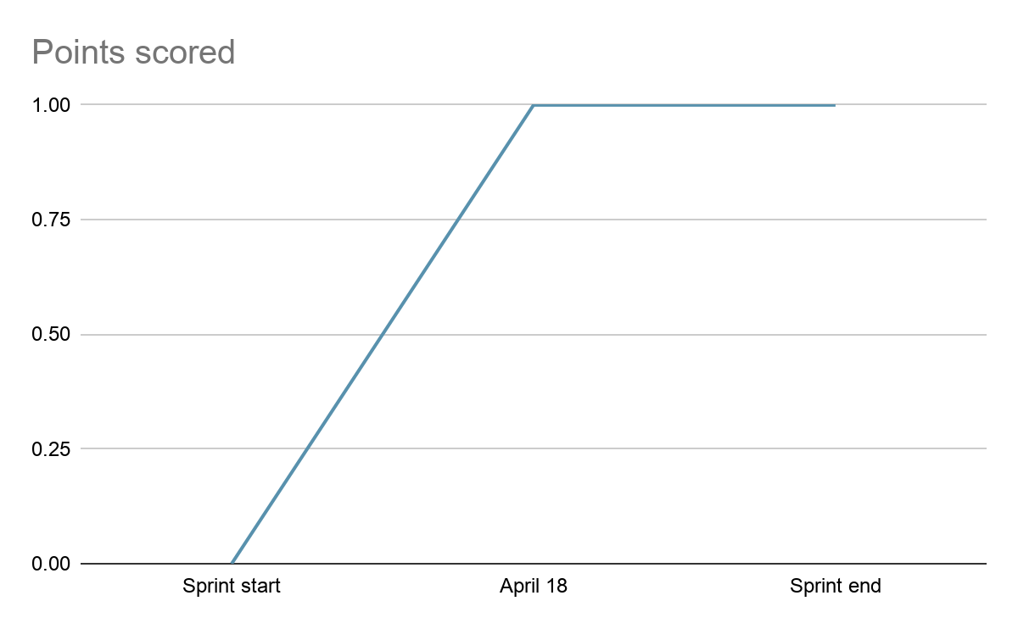

Task board:

|  |  |  |  |
| --- | --- | --- | --- |
| Tasks | Not started | In progress | Complete |
| Code academy/other |  |  | x |
| ~~Testing ionic~~ |  |  |  |
| ~~Postgresql~~ MongoDB research |  |  | x |
| Diagram |  |  | x |
| API research |  |  | x |

Scrum board:

Sundays 1pm

Tuesdays 3-4 (with TA)

Thursdays 10:30am